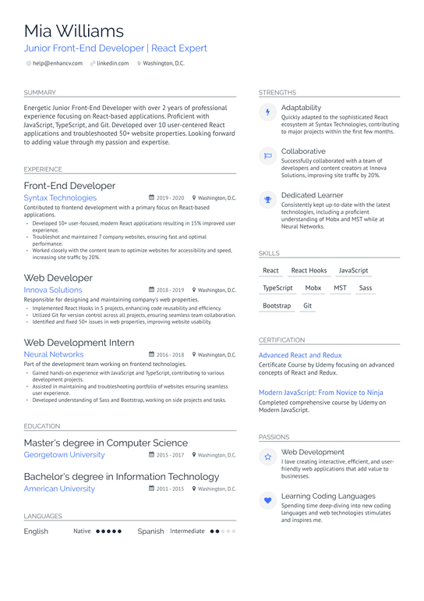
Mia Williams
Junior Front-End Developer | React Expert
@help@enhancv.com @linkedin.com
Washington, DC.
SUMMARY
Energetic Junior Front-End Developer with over 2 years of professional experience focusing on React-based applications. Proficient with JavaScript, TypeScript, and Git. Developed over 10 user-centered React applications and troubleshooted 50+ website properties. Looking forward to adding value through my passion and expertise.
EXPERIENCE
Front-End Developer
Syntax Technologies
2019-2020 Washington, DC.
Contributed to frontend development with a primary focus on React-based applications.
•Developed 10+ user-focused, modem React applications resulting in 15% improved user experience.
•Troubleshot and maintained 7 company websites, ensuring fast and optimal performance.
STRENGTHS
4
P
Adaptability
Quickly adapted to the sophisticated React ecosystem at Syntax Technologies, contributing to major projects within the first few months.
Collaborative
Successfully collaborated with a team of developers and content creators at Innova Solutions, improving site traffic by 20%.
Dedicated Learner
Consistently kept up-to-date with the latest technologies, including a proficient understanding of Mobx and MST while at Neural Networks.
•Worked closely with the content team to optimize websites for accessibility and speed. increasing site traffic by 20%
SKILLS
React React Hooks
JavaScript
Web Developer
Innova Solutions
I 2018-2019 Washington, DC.
TypeScript
Mobx
MST
Sass
Responsible for designing and maintaining company's web properties. Implemented React Hooks in 5 projects, enhancing code reusability and efficiency. Utilized Git for version control across all projects, ensuring seamless team collaboration. Identified and fixed 50+ issues in web properties, improving website usability
Bootstrap Git
Web Development Intern
Neural Networks
2016-2018 Washington, DC.
Part of the development team working on frontend technologies. ⚫Gained hands-on experience with JavaScript and TypeScript, contributing to various development projects.
Assisted in maintaining and troubleshooting portfolio of websites ensuring seamless user experience.
•Developed understanding of Sass and Bootstrap, working on side projects and tasks.
CERTIFICATION
Advanced React and Redux
Certificate Course by Udemy focusing on advanced concepts of React and Redux.
Modern JavaScript: From Novice to Ninja Completed comprehensive course by Udemy on Modern JavaScript.
EDUCATION
Master's degree in Computer Science Georgetown University
2015-2017 Washington, DC.
Bachelor's degree in Information Technology American University
2011-2015 Washington, DC.
LANGUAGES
English
Native..... Spanish Intermediate
PASSIONS
Web Development
I love creating interactive, efficient, and user- friendly web applications that add value to businesses.
Learning Coding Languages Spending time deep-diving into new coding languages and web technologies stimulates and inspires me.

